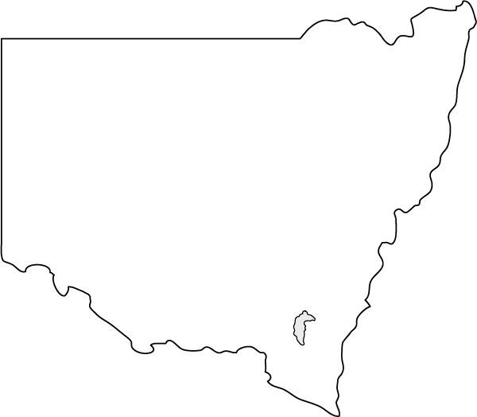
ATBSO NSW Inc Presents The
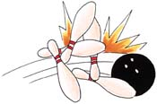
2013 GRAND SENIORS INVITATIONAL
PROUDLY
SPONSORED BY

We take pleasure in inviting all States
to enter Teams to this Once Only Tournament

Saturday 31st August 2013
Commencing at Approximately 4.00pm
&
Sunday 1st September 2013
Commencing at Approximately 2.30pm
at


114/92 Parramatta Road Lidcombe NSW
Phone 02 9737 8044

Online entries & all enquiries should be directed to:
Tournament Secretary: Vivienne Bissell Email: vivi.50@live.com.au
Mobile: 0425 353 090

ELIGIBILITY: This is a handicap event based on 90% of 210 and is open to all current ATBSO Members whose age is 60 or over prior to the event and have completed an All Events at the 2013 ATBSO National Championships.

AVERAGE: Averages will be based on the bowler’s national average obtained in ATBSO Tournaments taken on 31st July 2013 over a period of 12 months and a minimum of 30 games. If no ATBSO average is available your highest league average over a minimum of 30 games will be used.

FORMAT: Handicap Mixed Team Event
Each team will consist of 4 members with a minimum of 1 Male & 1 Female
The Winning Team will be decided over 8 games by way of total Pinfall + Handicap (4 games bowled each day)

COST: $75.00 per bowler

PRIZE FUND: 1st Place - $800.00
(Based on 12 Entries) 2nd Place - $600.00
3rd Place - $400.00

Only non cashing place getters are eligible for individual prize money
High Scratch Game Male - $50 High Scratch Game Female - $50
High Handicap Game Male - $50 High Handicap Game Female - $50

Page 2

Teams will be accepted to a maximum of 24 on a first in basis.
(Multiple State Teams will be allowed depending on numbers)
Please list name and contact information of the person submitting entry
 | Name |  | CONTACT NO. | Email Address

TEAM NAME & STATE: |  |  | ENTRY FEE: $300/Entry
TBA NO | ATBSO No | Name of Bowler | M/F | Average

TEAM NAME & STATE: |  |  | ENTRY FEE: $300/Entry
TBA NO | ATBSO No | Name of Bowler | M/F | Average

PAYMENT INFORMATION
Payment can be made by:
Direct Credit into ATBSO NSW No. 2 Account BSB: 062235 Account No: 10618618
Or
Post Hard Copy with Cheque made out to: ATBSO NSW NO 2 ACCOUNT To
Unit 7, No. 29 Mercury Street, Wollongong NSW 2500

Tournament Director: John Leo
Tournament Secretary: Vivienne Bissell
Email: vivi.50@live.com.au
Mobile: 0425 353 090

ALL TBA RULES AND REGULATIONS WILL APPLY

 Accreditation No: A13/0139

