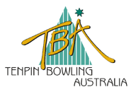

8th Australian Youth Teams Challenge 2010 Team Registration
Team :
Team Member Registration |  |  | Average  at 30.11.09
Women | Surname | First Name | Average  at 30.11.09
1
2
3
4
Coach :
Manager :
Team Member Registration |  |  | Average  at 30.11.09
Men | Surname | First Name | Average  at 30.11.09
1
2
3
4
Coach :
Manager :

Each bowler competing in the 2010 National Youth Team Challenge is required lodge a Ball Registration Form with the Tournament Committee prior to Day One of competition.

Please return completed Registration form to:

Tenpin Bowling Australia Ltd Tournament Team
PO Box 244
ALBION QLD 4010

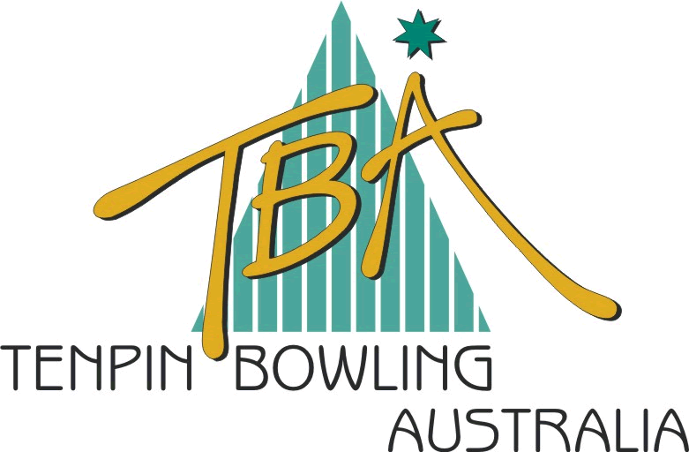 |  |  |  | 8th National Youth Teams Challenge  January 11th to January 14th, 2010  Bowling Ball Registration Form |  |  |  | TENPIN BOWLING AUSTRALIA LIMITED  ABN 72 085 023 721  P.O. Box 244, ALBION  Queensland, 4010  Tel : (07) 3262 4455  Fax : (07) 3262 5544  Website: www.tenpin.org.au
Team:
Name of Bowler:
 |  |  |  |  | Tournament Team Use:
 | Type & Brand |  |  | Serial No. | Gross Weight | Top Weight | Side Weight | Finger Weight | Thumb Weight | Hardness | Eligibility
1
2
3
4
5
6

Only bowling balls that are included on the ABC/WIBC Approved Bowling Ball list may be used in this competition.

Each player will be permitted to register a maximum 6 bowling balls. No replacements or additions will be allowed once the event has started. Completed ball registration forms must be lodged with the Tournament Technical Committee prior to the commencement of the event.

Each day during the event a random inspection of the bowling balls may be performed. The Tournament Committee will decide on the number of balls and the players, which will be randomly selected.

Penalties will apply for any for violation of the above rules (refer Technical Handbook).

