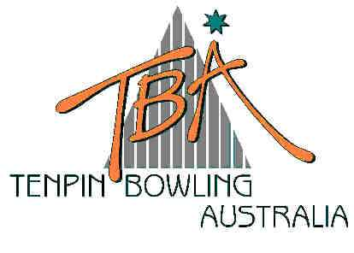
FOR IMMEDIATE RELEASE – Thursday, 10 July 2003
Tenpin Bowling
Australia Limited
ABN 72 085 023 721

PO Box 280
Church Point NSW 2105

Website: www.tenpin.org.au
email: lynne.clay@tenpin.org.au

Phone: (61) 2 9880 8866
Fax: (61) 2 9880 8844
Mobile:0419 444 280

AUSTRALIAN TENPIN BOWLING JUNIOR NATIONAL CHAMPIONSHIPS

President’s Shield Trophy – Interim results

For almost two weeks, Melbourne has been buzzing with bowling action as Junior (under 18 year-old) bowlers from every State and Territory in Australia compete in the sport’s annual Junior National Championships.

A major highlight of the Championships is the President’s Shield, an Interstate teams event that reverberates for three full days with noise, colour and action. Colourfully dressed in distinctive State and Zone uniforms, teams of 14 bowlers (seven boys and seven girls) from ten State and Territory Zones throughout Australia are represented in the President’s Shield Trophy competition. Winner of the Shield is determined by a point system, based on pinfall and points for win, lose or draw and last year North Queensland won the Shield.

The fierce, but friendly, competition was officially opened yesterday by Federal Member for Deakin, Phil Baressi MP, representing the Minister for Sport and the Arts, Senator The Hon. Rod Kemp, and Kirstie Marshall OAM, MLA for Forest Hill. Prior to cutting the green and gold ribbons that signalled the official opening of the tournament, Kirstie Marshall spoke of the importance of enjoying the competition of sport, drawing on her own illustrious career, while Phil Baressi focussed on the family values and widespread appeal of this popular sport.

Another eminent guest at the Opening Ceremony was the General Manager, Sport & Development of the Australian Sports Commission, Mr. Brent Espeland. He also spoke of the unique appeal and value of sport to our nation and commended the sport’s governing body – Tenpin Bowling Australia – for its initiative and success in providing pathways for its athletes.

Their words of encouragement were obviously heeded by 17year-old bowler Stephen Reynolds from Penrith in Sydney who bowled an outstanding 290 game in Game 5 of yesterday’s six-game block.

Day One leaders, NSW Central have been overtaken by Victoria after a further six games today, with the Victorians achieving a combined total of 112.5 points, ahead of NSW Central on 102 with South Queensland and ACT/Southern NSW tied on 94.5.

The noisy exuberance of supporters increases daily and an exciting finish is guaranteed tomorrow. Spectators are welcome to AMF’s Forest Hill Bowl to see and hear the fun and skill of tenpin bowling, which consistently features in official surveys of the top ten participation sports in Australia.

Scores can be viewed live daily on the website of the sport’s national governing body, Tenpin Bowling Australia – www.tenpin.org.au
ends

For further information, please contact TBA Media Director, Lynne Clay on 0419 444 280
or email lynne.clay@tenpin.org.au

